Smart Pointers
When you make a smart pointer and call a new with the help of that, then based on what smart pointer you use, the memory would be freed automatically at some point.
“new” allocates memory in the heap. delete frees that memory because it won’t be automatically deleted. Smart pointers are a way to automate that process. When you call new, you need not call delete to free that memory.

Unique Pointers
It is a scoped pointer. Gets deleted when it goes out of scope. They are unique. You can’t copy it. Because when it goes out of scope, one would get deleted and the other one would remain pointed to memory that has been freed.
Example:
When the scope ends, the pointer “entity” would automatically be destroyed (IN OUR CASE, THE DESTRUCTOR WOULD BE CALLED AND WE CAN SEE “Destroyed Entity” getting printed on console) and memory would be freed.
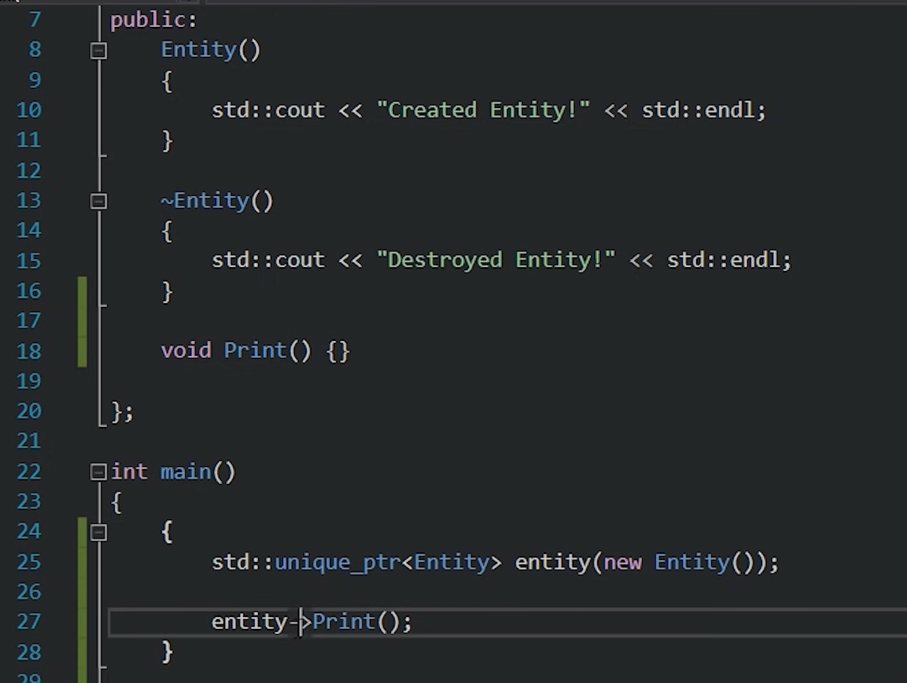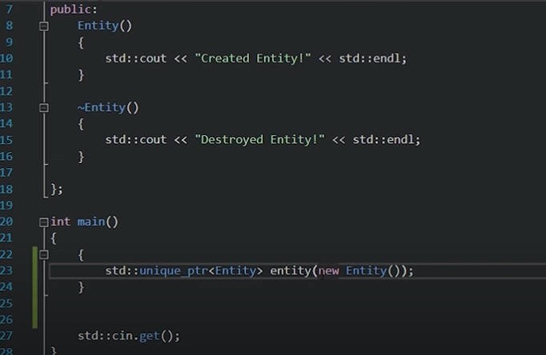

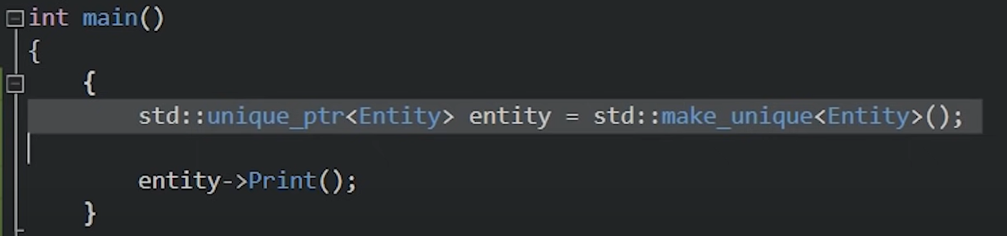
This is the preferred way to declare a unique pointer. It prevents exception error.
Can’t declare like this. Because the constructor has to be called explicitly
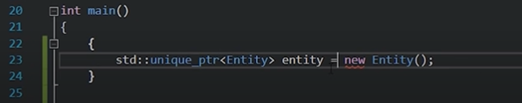
unique_ptr gets destroyed when it goes out of scope. So, what if we want to share a pointer outside the scope? We use “shared pointer”. It uses something called reference counting. Basically, we keep track of how many references we have to our pointer. As soon as it reaches 0, it gets deleted.
It also has to allocate another block of memory called “control block” where it keeps the reference count
Declaration:
Shared Pointer
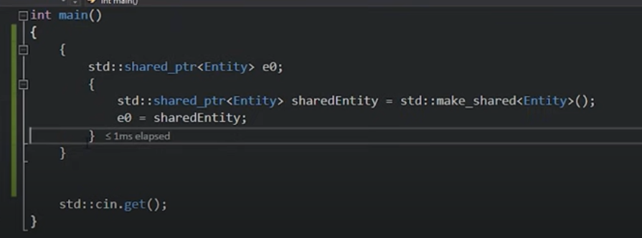

When the inner scope (L3) is over, “sharedEntity” would die. But since we assigned e0 also to the same pointer, the destructor won’t be called. But when the program goes out of outer scope(L2), it’d die and destructor is called because in that case, e0 also got destroyed and hence the count became 0. (sharedEntity and e0 were pointing to same address)

Weak Pointers
When you copy a shared pointer, it increases the reference count but when you assign a shared pointer to a weak pointer, it doesn’t do so.
Example:
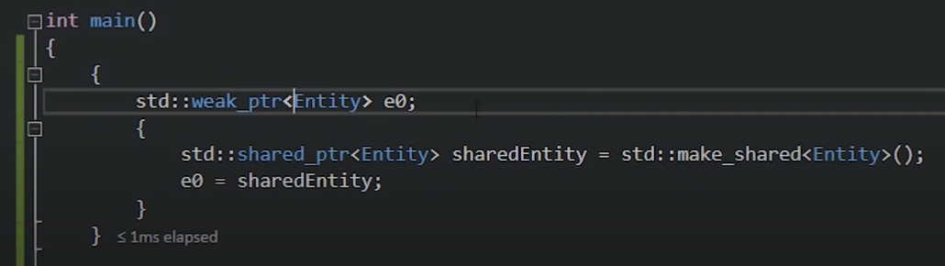
Here when scope (L2) gets over, weak pointer e0 won’t be destroyed but the memory pointed inside scope (L3) will get freed once that most inner scope (L3) gets over. So, the weak pointer isn’t destroyed but memory pointed by it was freed. So, it becomes a dangling pointer.

When should we use them?
Ummmm…..probably almost all the time, like whenever you can. Because it automates the memory management. There’s no fear of memory leakage if you use smart pointers.
Shared pointer has a little bit of overhead but that’s okay.

Some Questions:
What are dangling pointers? How to avoid them?
Ans: When a pointer points to a memory which has been freed, is called a dangling pointer. It happens when you free the memory but forgot to point the pointer (say ptr) to NULL.
What is memory leakage? How to avoid them?
Ans: When we dynamically allocate the memory and doesn’t use the delete keyword to free it. In that case, the pointer variable gets deleted out of scope but the memory isn’t freed. It also happens when we make a pointer null which was pointing to some memory before freeing that memory.
A pointer which has not been initialized to anything (not even NULL) is known as wild pointer.

Auto Keyword:
“auto” automatically deduces the data type of the content that we provide. For ex: auto x = 5; auto y = x; auto a = 5.5f; etc

ADVANTAGE:
Say we have a very big code and a function returns a string from that. Later if we decide to return int from that, then we just have to do a little modification in that function. If we don’t use auto, we have to change wherever string is there to int.

DISADVANTAGE:

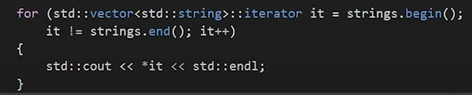
This isn’t much readable or good looking. Instead, we can use auto keyword as shown in pic below.

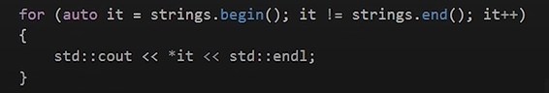

This is very much readable!

As shown in left, we can’t use member function on the returned string. It shows error. Even the pic below throws error.

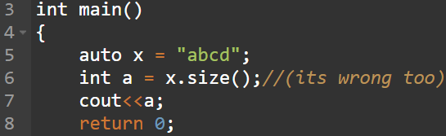

Some more use cases of auto:
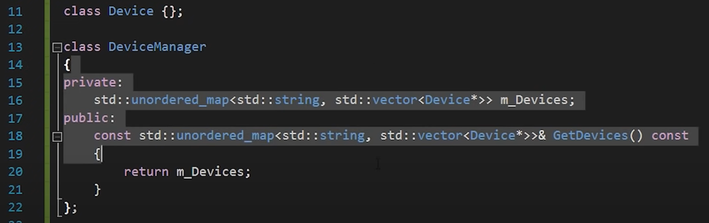

See how long is the data types in the class

One way to store the return value is to type the full name of the data type as shown in left pic.
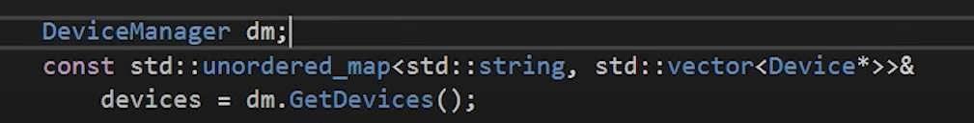

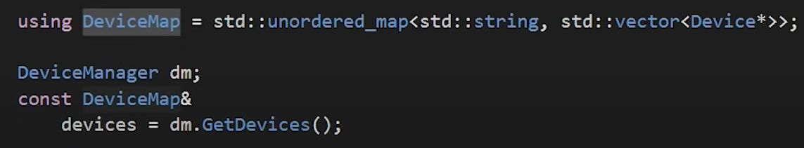
Another way is to use the “using” keyword

Another way is directly use the auto keyword! Note: We can remove the “&” keyword.
